**Exercise 4: Completing the solution**

Duration: 45 minutes

In this exercise, you will perform the final integration with the Computer Vision API and the Text Analytics API along with the Azure Machine Learning service you previously deployed, to deliver the completed proof of concept solution.

**Task 1: Deploy the Computer Vision API**

1. Navigate to the Azure Portal in your browser.
2. Select **Create a resource**.
3. Select **AI + Machine Learning** and then **Computer Vision**.  
   [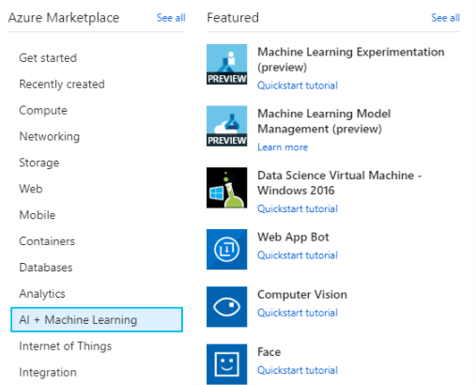](https://github.com/jumpstartninjatech/HeroSolutions-ML/blob/master/Day2/Cognitive-services-and-deep-learning/Hands-on%20lab/media/image19.png)
4. On the **Create** blade, provide the following:

a. **Name:** Provide a unique name for this instance.

b. **Subscription:** Select your Azure subscription.

c. **Location**: Select a location nearest your other deployed services.

d. **Pricing tier**: Select S1.

e. **Resource group**: Select the existing mcwailab resource group.

[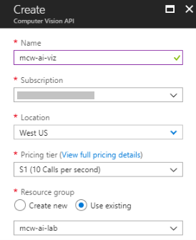](https://github.com/jumpstartninjatech/HeroSolutions-ML/blob/master/Day2/Cognitive-services-and-deep-learning/Hands-on%20lab/media/image60.png)

1. Select **Create**.
2. When the notification appears that the deployment succeeded, select **Go to resource**.

[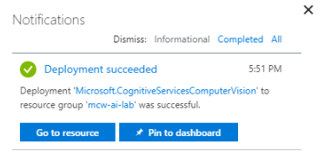](https://github.com/jumpstartninjatech/HeroSolutions-ML/blob/master/Day2/Cognitive-services-and-deep-learning/Hands-on%20lab/media/image61.png)

1. Select **Keys** and then copy the value of **Key 1** into notepad or something similar as you will need this value later in the lab.

[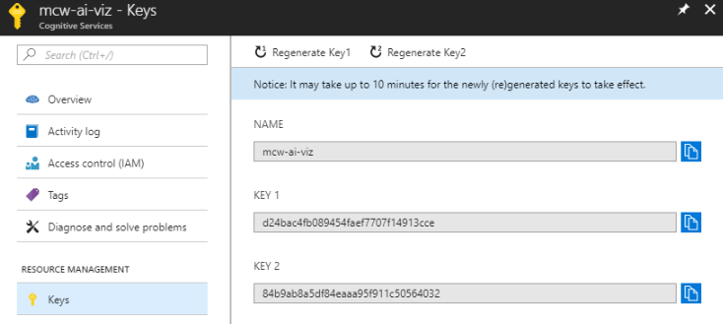](https://github.com/jumpstartninjatech/HeroSolutions-ML/blob/master/Day2/Cognitive-services-and-deep-learning/Hands-on%20lab/media/image62.png)

1. Select **Overview** and copy the value of Endpoint from the Essentials panel. Store this value in notepad or something similar as you will need this value later in the lab.

[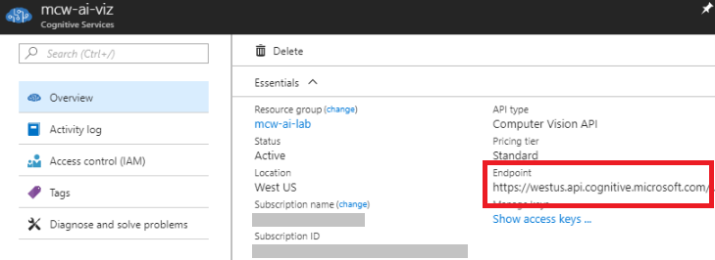](https://github.com/jumpstartninjatech/HeroSolutions-ML/blob/master/Day2/Cognitive-services-and-deep-learning/Hands-on%20lab/media/image63.png)

**Task 2: Deploy the Text Analytics API**

1. Navigate to the Azure Portal in your browser.
2. Select **Create a resource**.
3. Select **AI + Machine Learning** and then **Text Analytics**.

[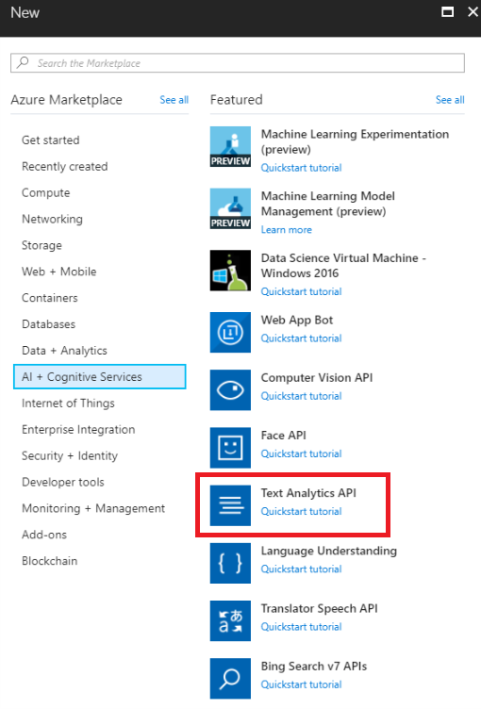](https://github.com/jumpstartninjatech/HeroSolutions-ML/blob/master/Day2/Cognitive-services-and-deep-learning/Hands-on%20lab/media/image64.png)

1. On the **Create** blade, provide the following:

a. **Name**: Provide a unique name for this instance.

b. **Subscription**: Select your Azure subscription.

c. **Location**: Select a location nearest your other deployed services.

d. **Pricing tier**: Select S0.

e. **Resource group**: Select the existing mcw-ai-lab resource group.

[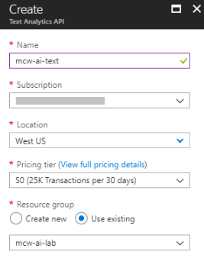](https://github.com/jumpstartninjatech/HeroSolutions-ML/blob/master/Day2/Cognitive-services-and-deep-learning/Hands-on%20lab/media/image65.png)

1. Select **Create**.
2. When the notification appears that the deployment succeeded, select **Go to resource**.

[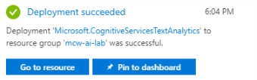](https://github.com/jumpstartninjatech/HeroSolutions-ML/blob/master/Day2/Cognitive-services-and-deep-learning/Hands-on%20lab/media/image66.png)

1. Select **Keys**, and then copy the value of **Key 1** into notepad or something similar as you will need this value later in the lab.

[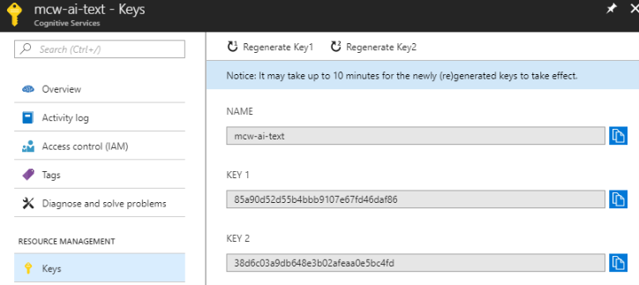](https://github.com/jumpstartninjatech/HeroSolutions-ML/blob/master/Day2/Cognitive-services-and-deep-learning/Hands-on%20lab/media/image67.png)

1. Select **Overview** and copy the value of Endpoint from the Essentials panel. Store this value in notepad or something similar as you will need this value later in the lab.

[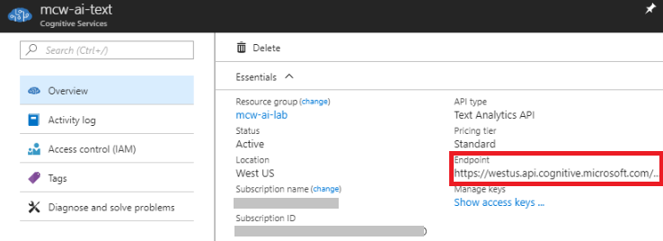](https://github.com/jumpstartninjatech/HeroSolutions-ML/blob/master/Day2/Cognitive-services-and-deep-learning/Hands-on%20lab/media/image68.png)

**Task 3: Completing the solution**

1. Return to your Azure Databricks Workspace. Select the Workspace item in the menu and navigate to the folder where you uploaded the Databricks Archive (which should be [your-name/AI-lab]), and select the notebook called 05 Cognitive Services. Follow the steps within the notebook to complete the lab and view the result of combining Cognitive Services with your Azure Machine Learning Services.